# Feedback Form PoC

## Final Acceptance Criteria for [PBI 52326](https://colliers.visualstudio.com/DefaultCollection/Colliers.com-v3/_workitems/edit/52326)

### Sitecore Editor Experience:

QA NOTE: The following acceptance criteria pertain to several related PBIs that are tagged No QA, including (but may not be limited to):

|  |
| --- |
| 53244 |
| 53088 |
| 50937 |
| 52512 |
| 50935 |

**Given** a Sitecore content editor

**When** I want to **embed a Feedback Form** into a content page on colliers.com

**Then** I can:

insert a rendering labeled “Sitecore Form”

and choose a config labeled “Sitecore Forms Config”

and the item will be set to en fallback

**Given** a Sitecore content editor

**When** I want to **configure an embedded Feedback Form** on a content page

**Then**: in the Sitecore Form Config > Form Settings > Form Item field

I can choose “Colliers/Feedback Form

And in the *Component Settings* section I can:

accept the default Title: How are we doing?

accept the default Introduction: We're always working to improve, so we'd like to hear from you about what's working and how we can do better.

or edit either field

and localize both fields

And in the *Internal Form Submission Notification* section I can:

see help text beside each field label

select *Notify by Email*

see help text with *Notify by Email* selection

accept the default "donotreply@colliers.com" *From* field

or edit the *From* field to a different email address (based on existing functionality)

input one or multiple email addresses in the *To* field, separated by commas

input one or multiple email addresses in the *CC* field, separated by commas

input an alias email address in any of the email address fields

Accept default form name OR edit text in the *Subject Line* field, and localize the text

Input internal instructional text in the *Additional Information* field

And in the *On-Screen Confirmation* section I can:

accept the default "Anonymous Title” and “Anonymous Confirmation Message” (see screenshot below)

accept the default “Contact Title” and “Contact Confirmation Message” (see screenshot below)

or edit any of these fields

and localize any or all of these fields

And in the rendering parameters I can:

Change background color

Change text alignment for title and introduction (all field labels are fixed at left-aligned)

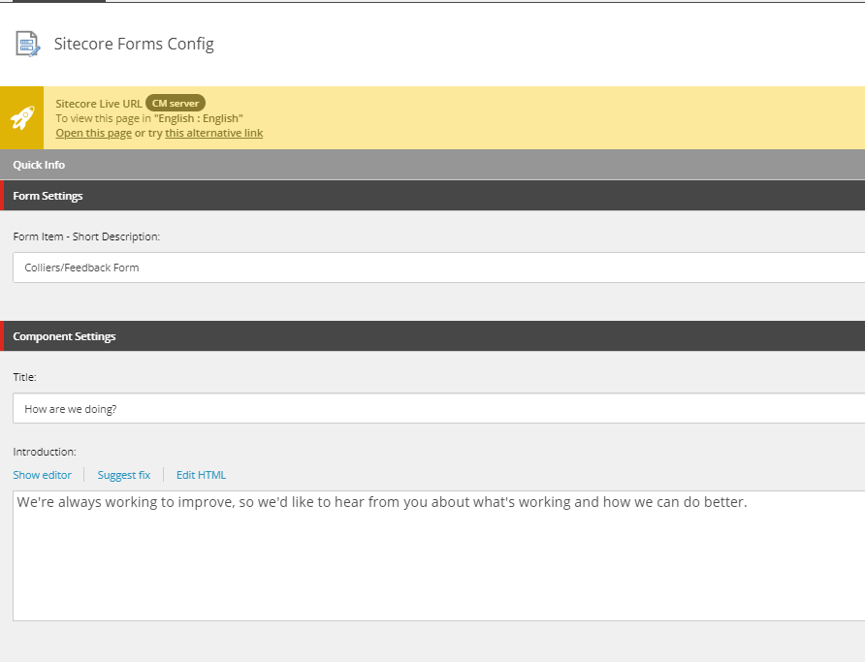

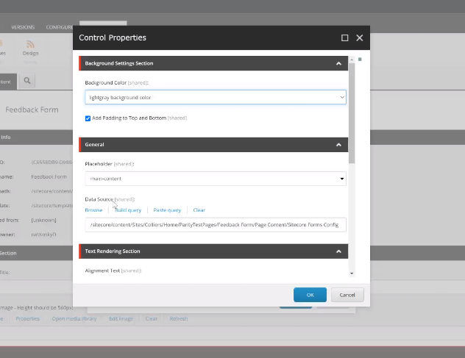

**Given** a Sitecore content editor

**When** I want to **launch a modal Feedback Form** from a content component on colliers.com

**Then** I can:

Insert a rendering labeled **“**Sitecore Form Modal”

And then choose“Sitecore Forms Modal Config”

And the config item will be set to en fallback

**Given** a Sitecore content editor

**When** I want to **configure modal Feedback Form** on a content page

**Then**: in the Sitecore Forms Modal Config > Form Settings > Form Item field

I can choose “Colliers/Feedback Form”

And in the *Component Settings* section I can:

add a single-line “CTA Title” and localize the text

add a single-line “Modal Title” and localize the text

add rich text “Modal Introduction” and localize the text

And all of the other config settings are the same as the embedded version, above

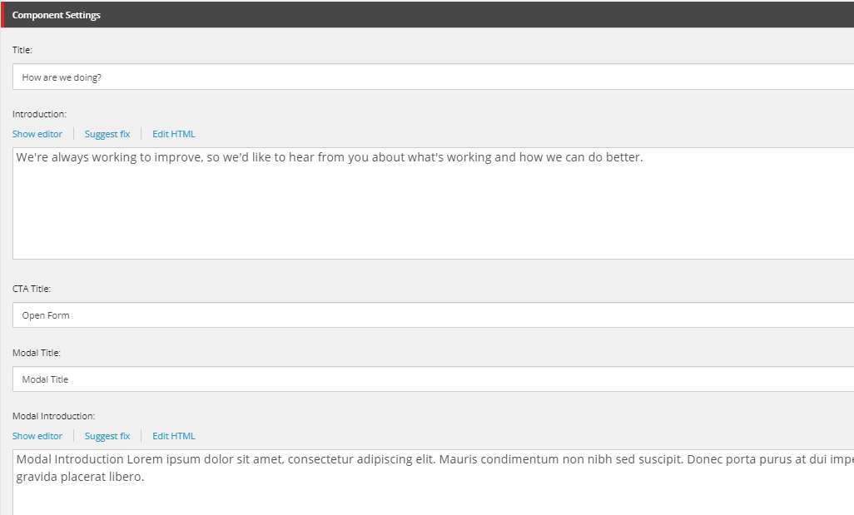

---------------------------------------------------------------------

### Visitor Experience:

**QA NOTE:** The following acceptance criteria pertain to several related PBIs that are tagged as NO QA, including (but may not be limited to):

|  |
| --- |
| 50935 |
| 50934 |
| 50936 |
| 50968 |
| 52462 |
| 52330 |
| 50933 |
| 53090 |
| 53431 |
| 53091 |

For general acceptance criteria that will apply to all Sitecore Forms, see:

<https://colliers.visualstudio.com/Colliers.com-v3/_wiki/wikis/Colliers.com-v3.wiki/621/All-Forms-Acceptance-Criteria>

**Given** a site visitor

**When** I first view a Feedback Form

**Then** I do not see any contact/consent fields

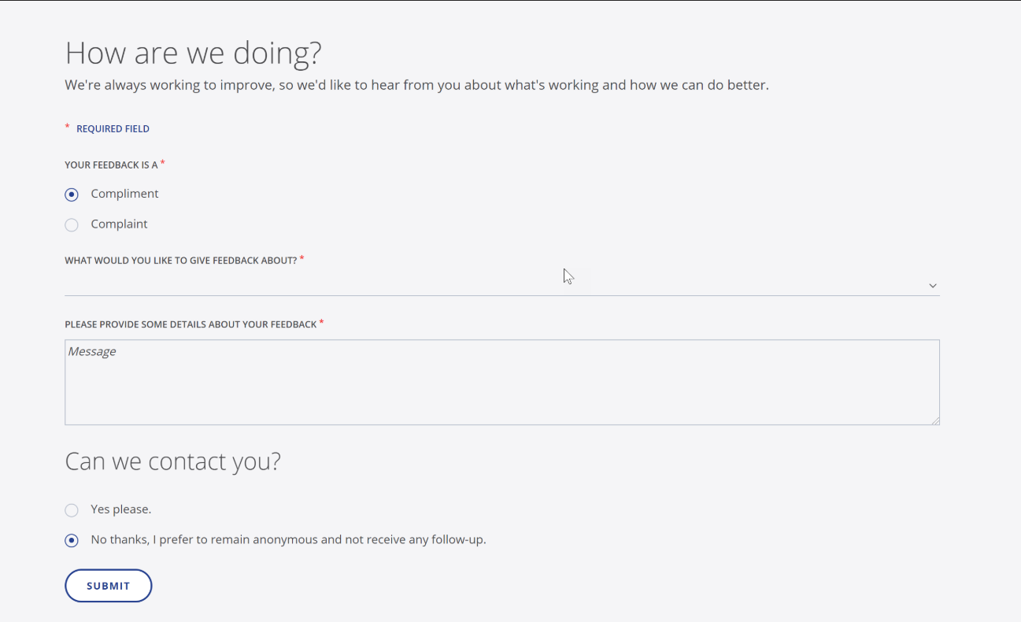

**Given** a site visitor

**When** I view a Feedback Form

**Then** I see these required fields indicated with a red asterisk

First View:

Your Feedback Is A:

What would you like to give feedback about?

Please provide some details about your feedback [compliment]

Please provide some details about your feedback [complaint]

How Would This Issue Best Be Resolved: [if complaint is chosen by user]

Only if visitor chooses “Yes” in the *Can We Contact You?*  Section

First Name

Last Name

Email

Consent paragraph #1 (Business Consent)

Consent paragraph #3 (Legal Consent)

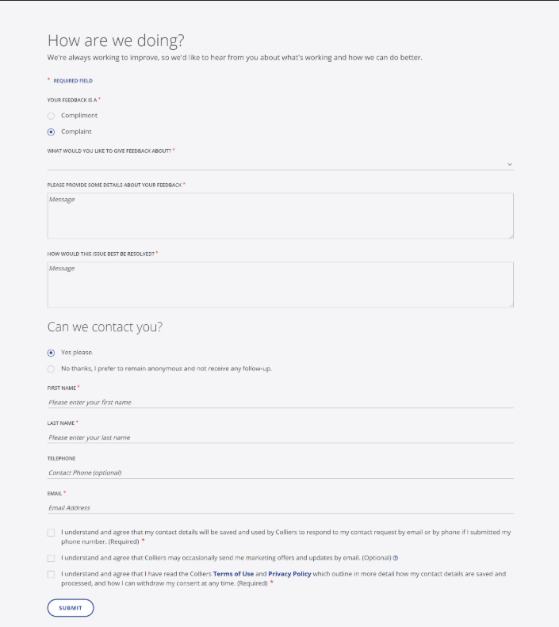

**Given** a site visitor

**When** I view a Feedback Form

**Then** I can choose between two types of feedback using a radio button:

Compliment

Complaint

**Given** a site visitor

**When** I choose "Compliment" as the feedback type

**Then** I have one required field I can add text to with default en label:

"Please provide some details about your feedback"

**Given** a site visitor

**When** I choose "Complaint" as the feedback type

**Then** I have two required fields I can add text to with default en labels:

"Please provide some details about your feedback"

"How Would This Issue Best Be Resolved?"

**Given** a site visitor

**When** I view a Feedback Form

**Then** I can choose the category of feedback from a dropdown list that includes these default categories:

Select

Our People

Our Service

Our Website

Our Communications

Something Else

**Given** a site visitor to a **regional site**

**When** I view a Feedback Form

**Then** I can choose a country from a dropdown list

And the country list includes all of the existing countries associated with that region

And there is a placeholder option at the top of the list “Select”

And there is no "other" choice

**Given** a site visitor who is completing the section labeled "Can we contact you?"

**When** I click the radio button for "No thanks, I prefer to remain anonymous and not receive any follow-up."

**Then** the contact and consent fields remain hidden

**Given** a site visitor who is completing the section labeled "Can we contact you?"

**When** I click the radio button for "Yes please"

**Then** the feedback form refreshes to display contact and consent fields

And I must enter first name, last name and email address

And I must make a selection in the first and third consent checkboxes

Or I cannot submit the form

**Given** a site visitor who chooses to submit a Feedback Form with contact details

**When** I successfully submit the form

**Then** the screen refreshes with a confirmation message as follows:

component title and introduction

checkmark icon

Thank you for taking the time to submit feedback to our team. Our team will need time to review and confirm if any further steps or communications will be provided.

**Given** a site visitor who chooses to submit a Feedback Form anonymously

**When** I successfully submit the form

**Then** the screen refreshes with a confirmation message as follows:

checkmark icon

Thank you for taking the time to submit feedback to our team. We appreciate your need to remain anonymous, and will not contact you further on this.

----------------------------------------------------------

### Submit Actions/Sitecore Actions:

[See Wiki](https://colliers.visualstudio.com/Colliers.com-v3/_wiki/wikis/Colliers.com-v3.wiki/621/All-Forms-Acceptance-Criteria) for A/C regarding

* validations (required fields, banned words, captcha)
* privacy (consent terms)
* branding
* accessibility

**Given** a Feedback Form

**When** a visitor successfully submits the form

**Then** form data is saved to Sitecore as follows: ([see 50930](https://colliers.visualstudio.com/DefaultCollection/Colliers.com-v3/_workitems/edit/50930) and [53243](https://colliers.visualstudio.com/DefaultCollection/Colliers.com-v3/_workitems/edit/53243))

Contact data is saved to dbo.ContactForms in the Extensions DB

Consent data is saved to dbo.ConsentSettings in the Extensions DB, with primary key = email address + country

Other form data references the contact form and is saved to dbo.SitecoreFormFields in the Extensions DB

**Given** a Feedback Form

**When** a visitor successfully submits the form

**Then** LastModifiedDate is updated to today's date to all three tables

**Given** a site visitor who submits a Feedback Form anonymously

**When** the form values are written to the Sitecore contact and consent tables: (see [53090](https://colliers.visualstudio.com/DefaultCollection/Colliers.com-v3/_workitems/edit/53090))

**Then**:

* Name = Anonymous
* First name = blank
* Last name = blank
* Email address = blank
* Consent record = doesn’t exist

**Given** a Feedback Form

**When** a visitor successfully submits the form

**Then** the submit action will check for anonymous vs contact form submission (see [53431](https://colliers.visualstudio.com/DefaultCollection/Colliers.com-v3/_workitems/edit/53431) and [53091](https://colliers.visualstudio.com/DefaultCollection/Colliers.com-v3/_workitems/edit/53091))

And then refresh the page with the appropriate version of on-screen confirmation

Anonymous: Thank you for taking the time to submit feedback to our team. Our team will need time to review and confirm if any further steps or communications will be provided.

Contact: Thank you for taking the time to submit feedback to our team. Our team will need time to review and confirm if any further steps or communications will be provided.

**Given** a Sitecore Forms Config *Internal Form Submission Confirmation* section where "Notify By Email" is selected and email fields contain values

**When** a QA tester submits a Feedback Form (either embedded or modal) in a **lower environment**

**Then** an email notification is configured to send to the Colliers experts listed in the "To" and "CC" fields in the config item BUT delivered to the test email directory for that environment ("~\temp\Emails")

**Given** a Sitecore Forms Config *Internal Form Submission Confirmation* section where "Notify By Email" is selected and email fields contain values

**When** a site visitor submits a Feedback Form (either embedded or modal, either anonymous or contact)

**Then** an email notification is sent to the Colliers experts listed in the "To" and "CC" fields in the config item

**Given** an internal email notification for a Feedback Form that was submitted with contact details

**When** the email is received by the listed Colliers expert

**Then** it contains the following information:

Contact Form Details*: first & last name (required), phone (optional so may not display), email (required)

Feedback Form Details: English-only field labels with field values in the language of input

Colliers privacy alert notice (accurate as per #52930)

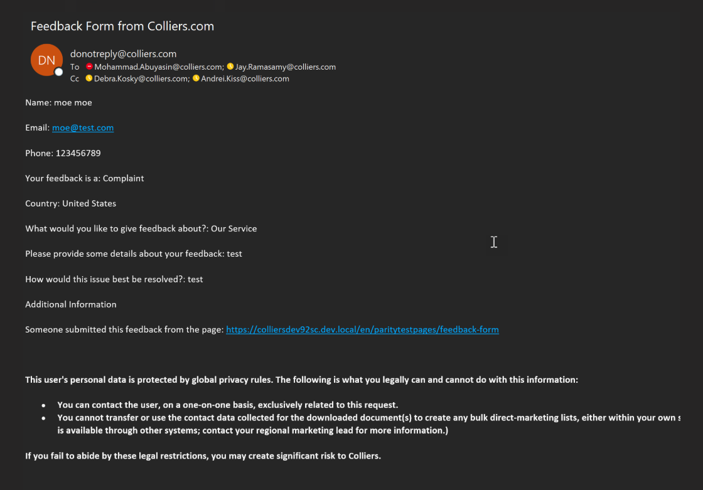

**Given** an internal email notification for a Feedback Form that was submitted anonymously

**When** the email is received by the listed Colliers expert

**Then** it contains the following information:

Contact Form Details: Name = Anonymous

Feedback Form Details: English-only field labels with field values in the language of input

Colliers privacy alert notice (accurate as per #52930)

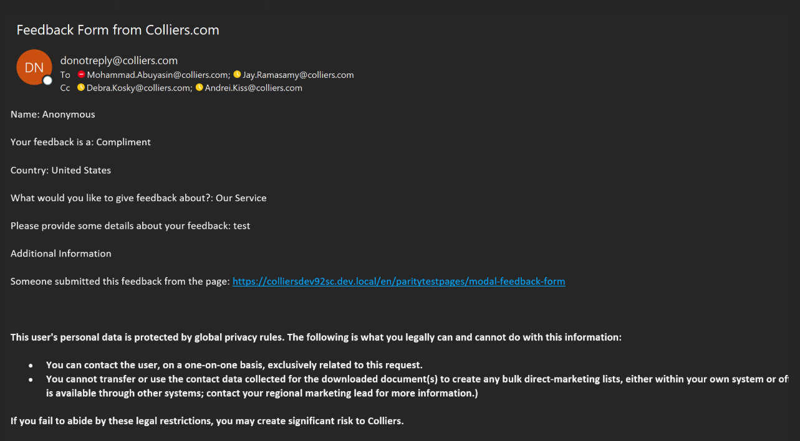

**Given** a Sitecore Forms Config *Internal Form Submission Confirmation* section where "Notify By Email" is NOT selected and email fields are blank

**When** a site visitor submits a Feedback Form (either embedded or modal)

**Then** an email notification is NOT sent internally, but the data is saved to Sitecore tables for dissemination to Cinchy

--------------------------------------------------------------

### Analytics Experience:

Sitecore Analytics

Google Analytics