

Press release
Cushman & Wakefield: +421 259 209 333
CBRE: +421 232 553 300
Colliers International: +421 259 980 980
JLL: +421 259 209 931

October 24th 2019, Bratislava

Bratislava Research Forum Announces

Office Market Figures for Q3 2019

Introduction

The Bratislava Research Forum is pleased to announce Office Market figures for Q3 2019.

The members of the Bratislava Research Forum (BRF) – Cushman and Wakefield, CBRE, Colliers International and JLL share non-sensitive information with the aim of providing clients and public with consistent, accurate and transparent data about the Bratislava office market.

The market is classified into city centre, inner city and outer city as outlined in the plan below to allow a simplified analysis. In addition, data is collected also according to Bratislava districts.

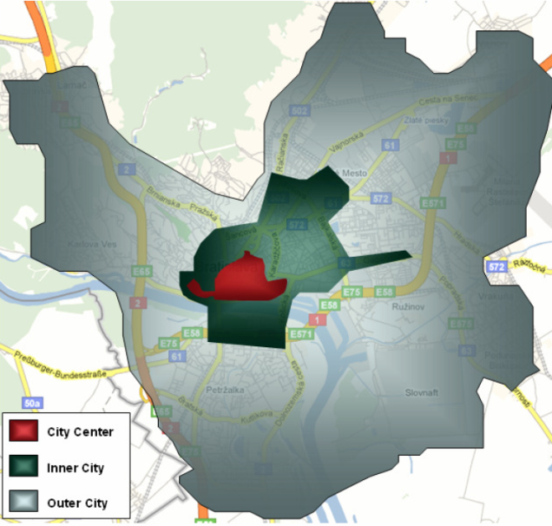

Office Supply/Stock

In the third quarter of 2019, the total office stock of A and B Grade quality in Bratislava amounts to more than 1.8 million square meters. 62% of the space is represented by A-class office space and 38% by B-Class office space.

Total modern stock according to Bratislava districts
Total modern stock according to BRF classification

In the third quarter of 2019, there wasn´t completed any new office building in Bratislava. There are seven office buildings under construction to be completed in 2019/2020 and these will bring approx. 118,000 sq m of area to the Bratislava office market.

Green Certified Buildings

Within the total office stock 32 buildings, representing more than 621,000 sq m or approx. 34% of the total stock, have secured certification as green/sustainable developments – either LEED or BREEAM ratings.

Transactions on the Office space market (Office Take-up)

Transactions that have been concluded in the third quarter of 2019 amount almost 27,000 sq m, which represents 68% decrease of the let area compared to the previous quarter. Renegotiations represented 46% of all transactions, new leases secured 41%, pre-leases represented 8% and share of 5% was attributed to expansions.
There were three bigger leasing transaction (renegotiations) recorded in a total size of 4,000 sq m, 2,800 sq m and 2,206 sq m. In addition, we monitored another two transactions with the area of over 1,000 sq m.
In the third quarter of 2019, the majority of all transactions were signed within the Professional services sector (28%) and IT sector (26%).

Office Take-Up according to sector for the third quarter of 2019:

Significant Office Transactions

Property | Let area (sq m) | Occupation | Type of deal
AC Ružová dolina | 4000 | Public/Embassy/Trade Council/Diplomatic | Renegotiation
Galvaniho Business Center III | 2800 | IT | Renegotiation
Digital Park | 2208 | Prof. services | Renegotiation
Einpark Offices | 1506 | IT | Pre-lease
Eurovea Central | 1080 | Finance/ Banking/Insurance | New lease
Zuckermandel Hill Side | 968 | Prof. services | New lease
Green Point Offices | 927 | Manufacturing/Construction | New lease
Green Point Offices | 927 | Manufacturing/Construction | New lease
AC Ružová dolina | 917 | Public/Embassy/Trade Council/Diplomatic | New lease
Apollo Business Center II | 900 | Prof. services | Renegotiation
Lazaretská 12 | 851 | IT | Renegotiation

Office Vacancy

The overall vacancy rate in the third quarter of 2019 for Bratislava has increased to 8.80% from 8.06% in the previous quarter. The lowest vacancy rates were recorded in Bratislava III (3.69%), followed by Bratislava I (6.04%), Bratislava II (9.12%) and Bratislava V (9.33%). The highest vacancy rate was recorded in Bratislava IV, in the level of 30.93%.

Prime Rent

The Prime Rent remained unchanged at 17.00 EUR/sq m/month.

For further information please contact any member of the Bratislava Research Forum.







Definitions

Stock: Total completed office space (occupied and vacant), newly built since 1993 or refurbished, A and B class offices, owner occupied and for lease. Public authorities’ buildings and buildings fewer than 800 sq m are excluded.

New supply: Completed newly built or refurbished buildings that obtained a use permit in the given period.
A-Class office building: Reflects an above average fullfilment of the specific criteria including the following: integrated air conditioning system, limited total floor depth, floor to ceiling height minimum of 2.75m, flexibility of internal design, either three compartment trunking for telephones, electricity and computer cable or raised floors/suspended ceilings, manned reception and covered access to car parking, lift access and disabled access, dual power supply and/or power supply system back-up.

B-Class office building: Reflects an average or typical property in that market based on the above mentioned criteria.

Take-up: A gross figure representing the total floor space known to have been let or pre-let, sold or pre-sold to tenants or owner-occupiers over a specified period of time. It does not include space that is under offer. A property is taken up when the contract is signed. Total take-up includes re-negotiations, net take-up excludes re-negotiations.

Pre-lease: Active pre-leasing for an office building begins as soon as preliminary design drawings are ready to show to prospective tenants. Pre-leasing occurs until the start of construction.

Vacancy rate: Ratio of physically vacant space in completed buildings as a percentage of the total stock.
Prime rent: Achieved rents that relate to new prime, high specification units in prime locations.

COPYRIGHT © Bratislava Research Forum 2018

This publication is the sole property of the Bratislava Research Forum, (Members: Cushman and Wakefield, CBRE, Colliers International and Jones Lang LaSalle) and must not be copied, reproduced or transmitted in any form or by any means, either in whole or in part, without the prior written consent of the Bratislava Research Forum. The information contained in this publication has been obtained from sources generally regarded to be reliable. However, no representation is made, or warranty given, in respect of the accuracy of this information. We would like to be informed of any inaccuracies so that we may correct them. The Bratislava Research Forum, does not accept any liability in negligence or otherwise for any loss or damage suffered by any party resulting from reliance on this publication.

